ReactJS Hands-On Lab - Output Report

Objective
Create a React application and display a message: "Welcome to the first session of React".

Environment Setup
Verified Node.js and npm versions installed:
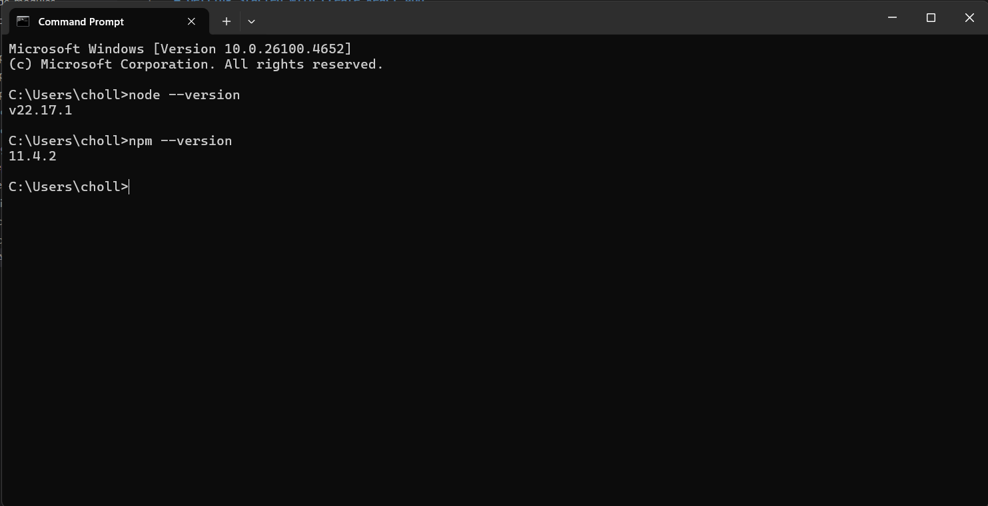

Project Setup
Created a new React project using create-react-app and opened it in Visual Studio Code:
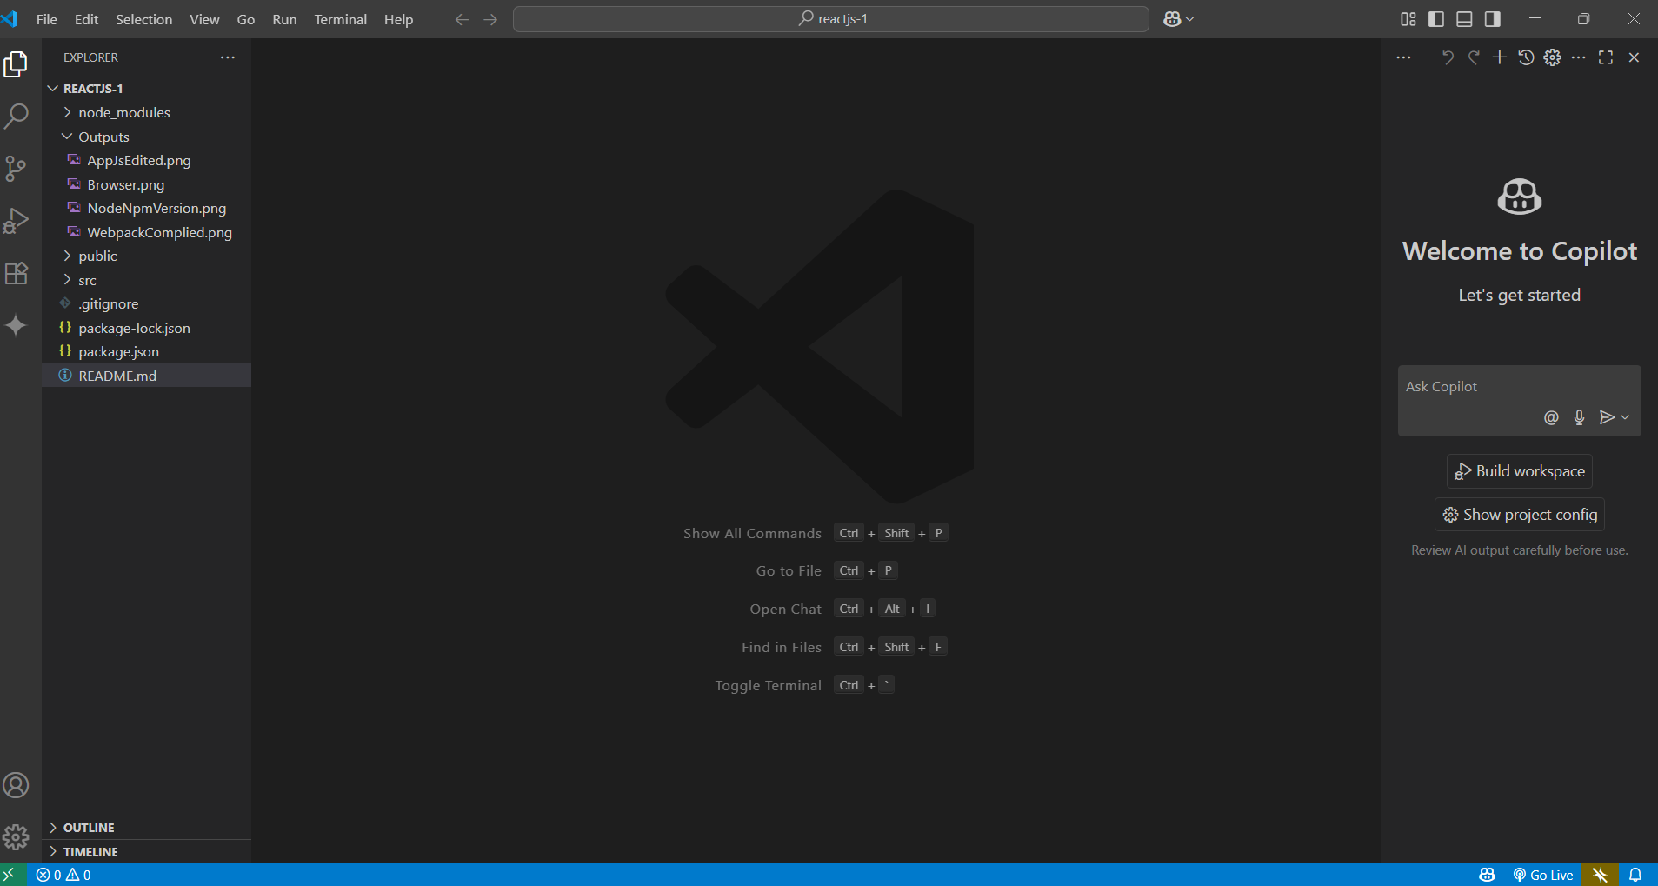

Edited App.js
Modified the App.js file to display the required message:
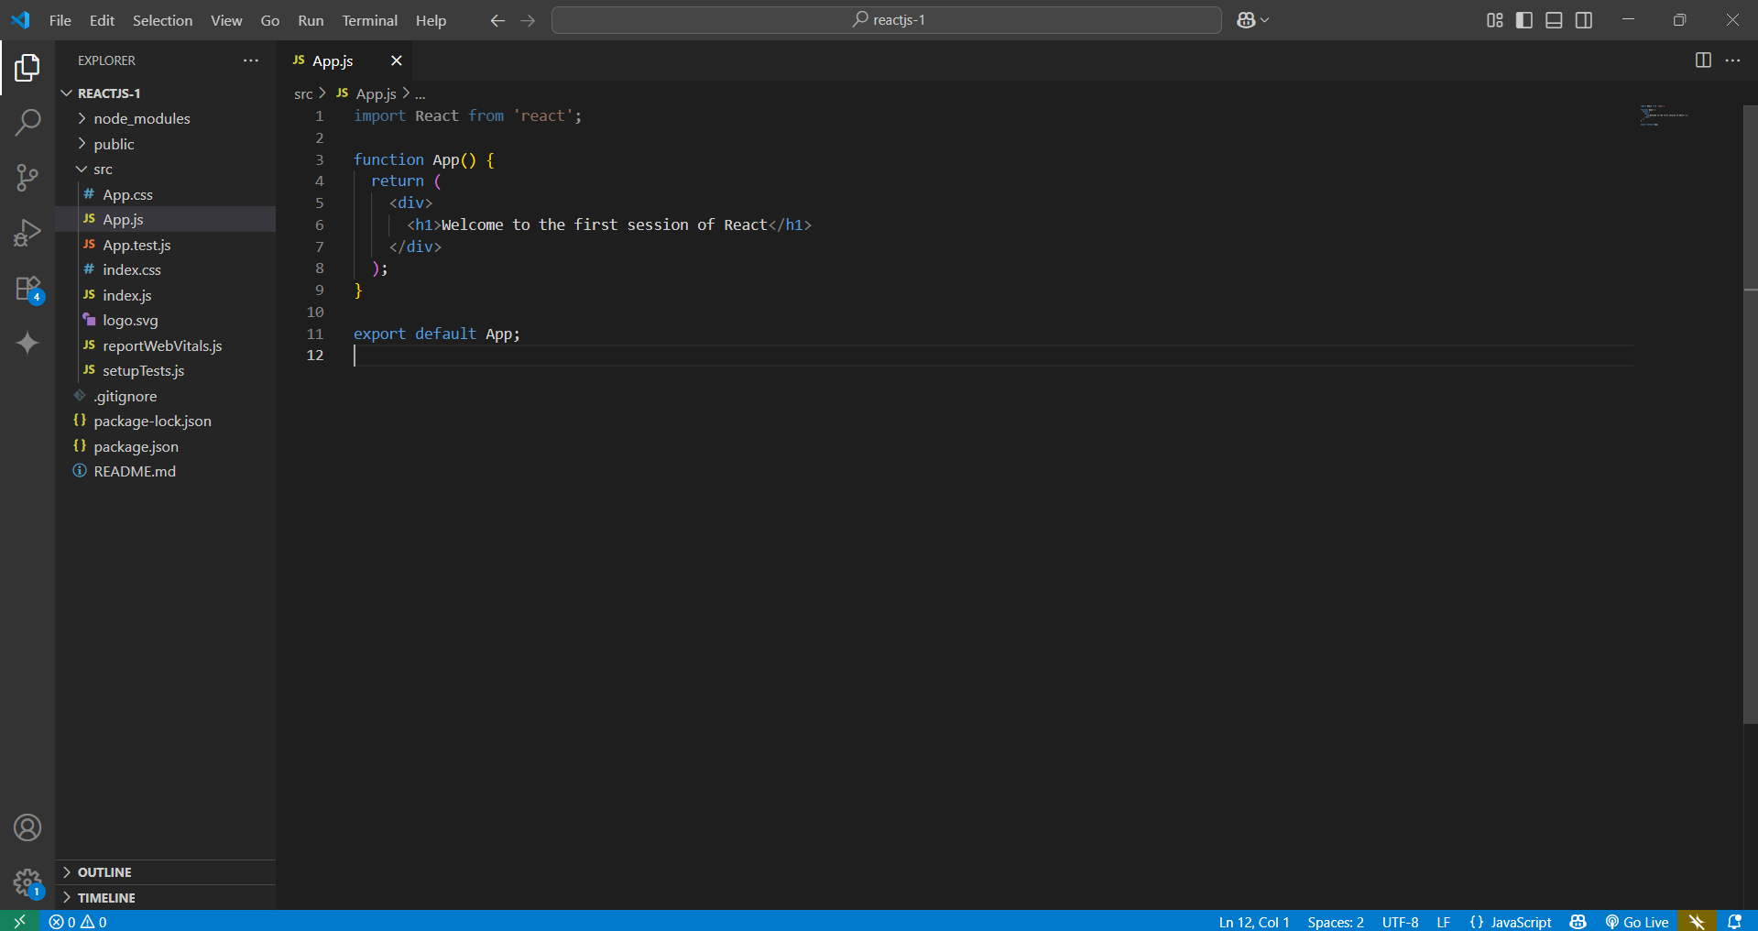

Webpack Compilation
Started the development server and verified successful compilation:
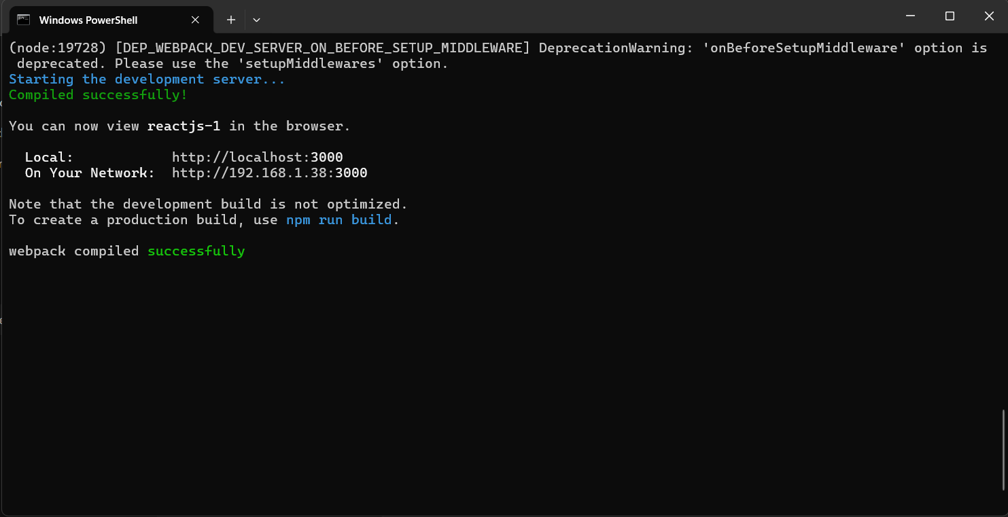

Browser Output
Verified that the React app displays the message in the browser:
